**THE GREEN AI PROFILER  
  
NAVIGATING THE INTERSECTION OF PERFORMANCE AND SUSTAINABILITY  
  
Raghav Kapoor, Aditya Agrawal and Jayanth Siddalingappa**

**Abstract:** The exponential growth of Artificial Intelligence has an often-overlooked environmental cost, with ***large-scale model training*** contributing significantly to global carbon emissions. Data scientists and ML engineers currently lack integrated tools to make environmentally conscious decisions without sacrificing performance. *The* ***Green AI Profiler*** is a novel, ***self-service recommendation engine*** that addresses this gap. By taking a simple project description as a prompt, it analyses various combinations of AI models, hardware accelerators, and data centre locations to provide a ranked list of solutions optimized for both performance and a minimal carbon footprint. Our accompanying dashboard visualizes these trade-offs, empowering developers to build powerful AI systems that are also sustainable by design.

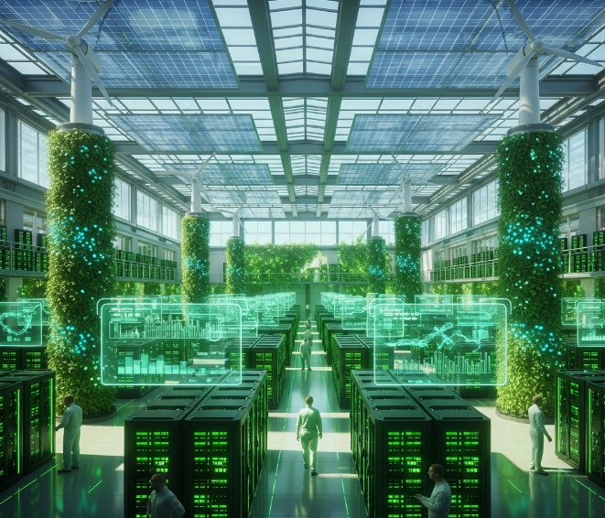

1. **The Problem: The Hidden Cost of Intelligence:**

The AI revolution is powered by massive computational resources. This has led to a critical, yet often ignored, problem: the environmental impact of AI.

* **Massive Energy Consumption:** Training a *single large AI model* can emit ***more carbon than five cars in their lifetimes***. For example, training *GPT-3* was estimated to have consumed nearly *1,300 MWh of electricity*, resulting in over *550 tons of CO₂ emissions*.
* **Lack of Integrated Tools:** There is no single tool that holistically analyses a project's needs and provides a simple, actionable recommendation that balances performance with sustainability.
* **Decision Paralysis:** Developers are focused on metrics like accuracy, latency, and cost. They lack the visibility and data to factor environmental impact into their choices. Key decisions are fragmented:
* Which **model architecture is most efficient**? (*e.g., BERT vs. Distil BERT vs. ALBERT*)
* Which **hardware is best**? (*e.g., NVIDIA A100 vs. H100 vs. Google TPU*)
* Which **data centre region is the greenest**? (A data centre in a region powered by renewables is far better than one powered by fossil fuels).
* 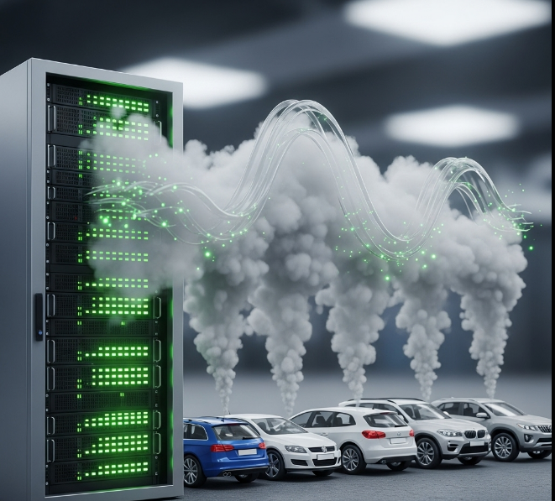

1. **Our Solution: The Green AI Profiler💡**

The Green AI Profiler is a self-service tool that makes sustainable AI an easy choice, not a difficult one. Think of it as **Google Maps for your AI project**; it finds the most efficient route, considering not just speed (performance) but also fuel consumption (carbon footprint).

A user provides a natural language prompt describing their project:

*"I need to fine-tune a large language model for legal document summarization. My dataset has 500,000 documents. I am targeting a ROUGE score of 0.4 and low inference latency."*

The Profiler processes this prompt and returns a set of ranked recommendations.

**Example Recommendation:**

* **Option 1 (Most Eco-Friendly):**
  + **Model:** Llama-3-8B-Instruct (Quantized)
  + **Hardware:** NVIDIA L4 GPU
  + **Data Centre:** Google Cloud - europe-west1 (Belgium)
  + **Reasoning:** Excellent balance of performance for the task. The L4 GPU is highly power-efficient for inference, and the Belgium region has a very low carbon intensity (gCO₂eq/kWh) due to its reliance on nuclear and renewables.
* **Option 2 (Balanced):**
  + **Model:** Mistral-7B-Instruct-v0.2
  + **Hardware:** NVIDIA A100
  + **Data Centre:** AWS - ca-central-1 (Canada)
  + **Reasoning:** Higher performance with the A100, and Canada's grid is largely powered by hydropower, offering a good compromise between raw power and sustainability.



1. **How It Works: The Recommendation Engine:**

The Profiler is built on a ***three-tiered architecture*** that combines a knowledge base with a smart recommendation algorithm.

**1. Input Parser (The Ears):**

* Uses a Language Model (like Gemini, SOGPT, ChatGPT etc.) to parse the user's prompt and extract key entities:
  + **AI Task:** (e.g., Classification, Summarization, Image Generation)
  + **Data Scale:** (e.g., 1M images, 500k documents)
  + **Model Type:** (e.g., LLM, Transformer, CNN)
  + **Performance Constraints:** (e.g., target accuracy, latency requirements)

2. **Knowledge Base (The Brain):**

* A continuously updated database containing:
  + **AI Models:** Information on popular models (e.g., parameter count, typical FLOPs for training/inference, benchmark performance).
  + **Hardware Specs:** Data on GPUs and TPUs (e.g., power draw, performance on common benchmarks, cost per hour).
  + **Data Centre Grids:** Real-time or near-real-time data on the Carbon Intensity (gCO₂eq/kWh) and Power Usage Effectiveness (PUE) of major cloud provider regions worldwide. This can be sourced from APIs like electricitymaps.com or watttime.org.

**3. Estimation & Ranking Algorithm (The Logic):**

* For a given parsed request, the algorithm iterates through feasible combinations of models, hardware, and locations.
* For each combination, it calculates key metrics using the following simplified formula:
  + **Total Energy (kWh)** = (Hardware Power Draw * Training Time) * PUE
  + **Total Carbon Footprint (kgCO₂)** = Total Energy (kWh) * Carbon Intensity (kgCO₂/kWh)
* It then ranks the combinations based on a weighted score that considers carbon footprint, estimated cost, and predicted performance, presenting the top choices to the user.

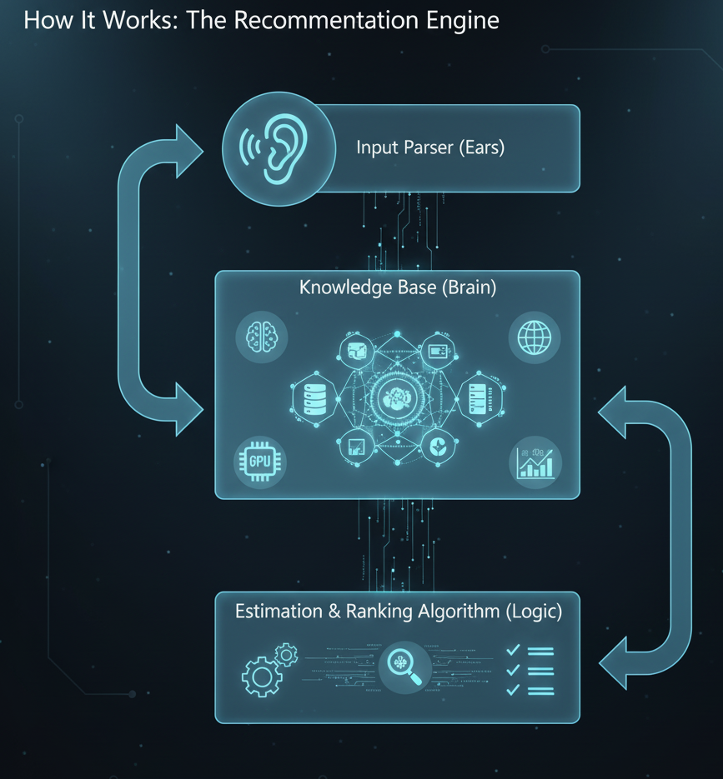

1. **The Dashboard: Visualizing the Green Impact 📊**

The dashboard provides an interactive and intuitive way to explore the recommendations.

* **Comparison View:** Use bar charts or radar charts to compare the top 3-5 recommendations across key axes: ***Carbon Emissions****,* ***Estimated Cost****,* ***Training Time****, and* ***Performance Score****.*
* **Geospatial Map:** A world map color-coded by the real-time carbon intensity of the electrical grid. This visually communicates *why* choosing a data centre in Finland might be better than one in Virginia at a given time.
* **"What-If" Analysis:** Interactive sliders allow users to see how recommendations change if they adjust their constraints. For example, "What if I can tolerate 5% lower accuracy?" The tool might suggest a much smaller, more efficient model.

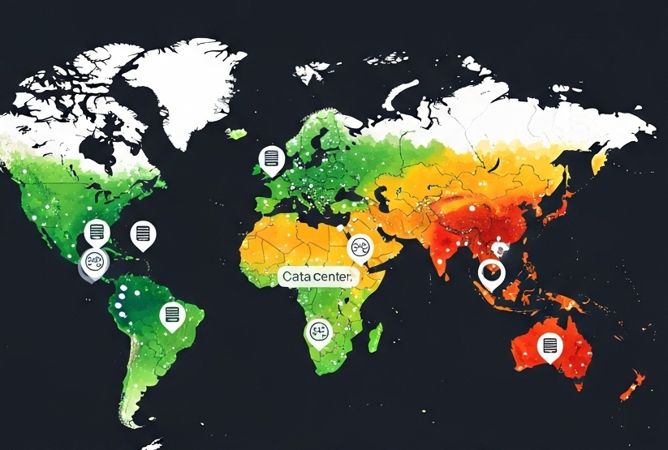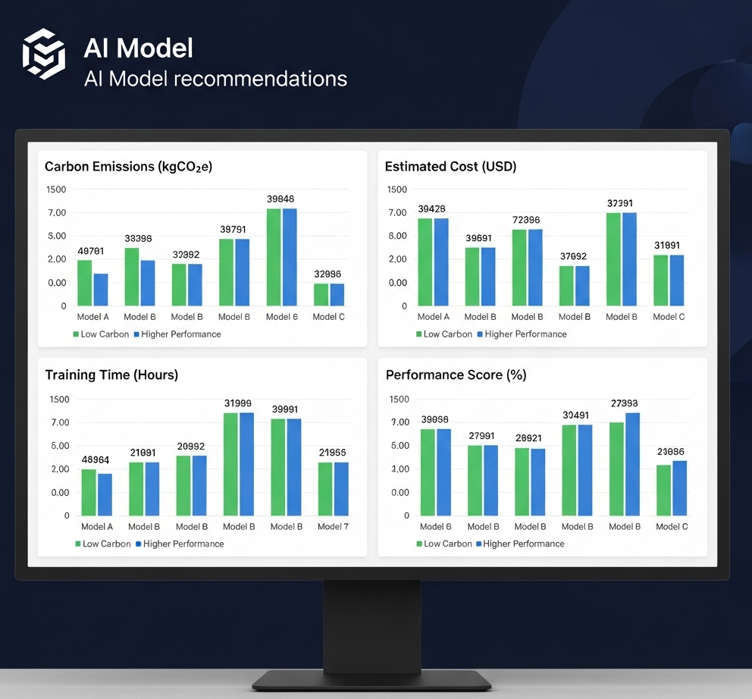

\

1. **Implementation Plan & Tech Stack:**

To demonstrate the feasibility of bringing the Green AI Profiler to life, we have outlined a clear implementation path for a Minimum Viable Product (MVP). This illustrates that our concept is grounded in practical, accessible technology.

* **Frontend:** **Streamlit** or **Gradio** would be ideal for rapidly developing a proof-of-concept UI, allowing users to interact with the profiler.
* **Backend:** **Python** with a lightweight framework like **Flask** or **Fast API** would serve the core logic and handle API requests.
* **Prompt Parsing:** The **SOGPT API or any other LLM** could be leveraged for its state-of-the-art natural language understanding to accurately parse user project descriptions.
* **Knowledge Base:** An initial version could use a static **CSV or JSON file** containing pre-compiled data for a curated set of popular models, hardware, and cloud regions.
* **Data Visualization:** **Plotly** or **Altair** libraries would be used to render the interactive charts and maps for the dashboard.

1. **Impact and Future Scope:**

* **Immediate Impact:** Empowers developers to make data-driven, sustainable choices, potentially reducing the carbon footprint of new AI projects by **30-50% or more**.
* **Future Scope:**
  + **Real-time Monitoring:** Integrate with cloud provider APIs to monitor the *actual* energy consumption of a running job, not just an estimate.
  + **MLOps Integration:** Develop plugins for popular platforms like Kubeflow, ML flow, and Weights & Biases.
  + **Inference Optimization:** Expand the profiler to provide recommendations for deploying models for inference, which often accounts for the majority of a model's lifetime energy use.
  + **Embodied Carbon:** Include the carbon cost of manufacturing the hardware itself in the calculations for a true cradle-to-grave analysis.

**By building the Green AI Profiler, we are not just creating a tool; we are fostering a culture of sustainability within the AI community. We are making "Green AI" the new standard.**